# Unity Store Example

## Invoice

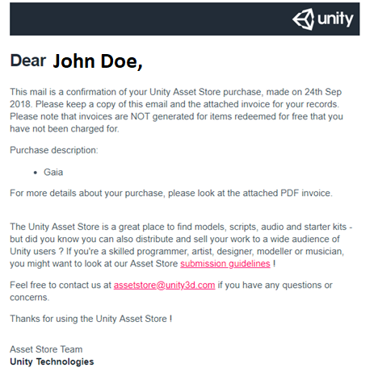

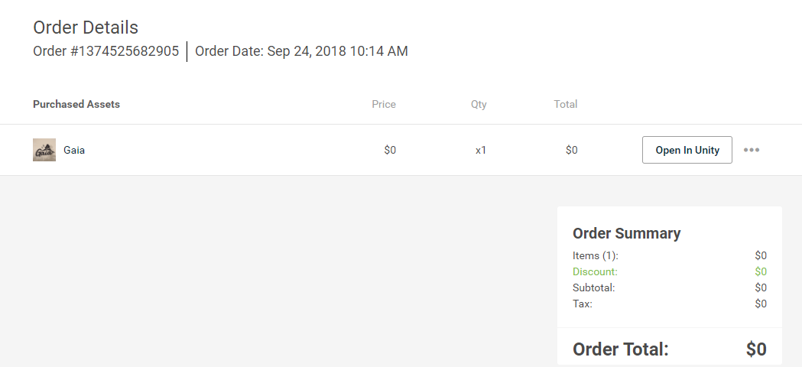

### Attributes (0NF)

### 1NF

### 2NF

### 3NF

### ERD

## Product View

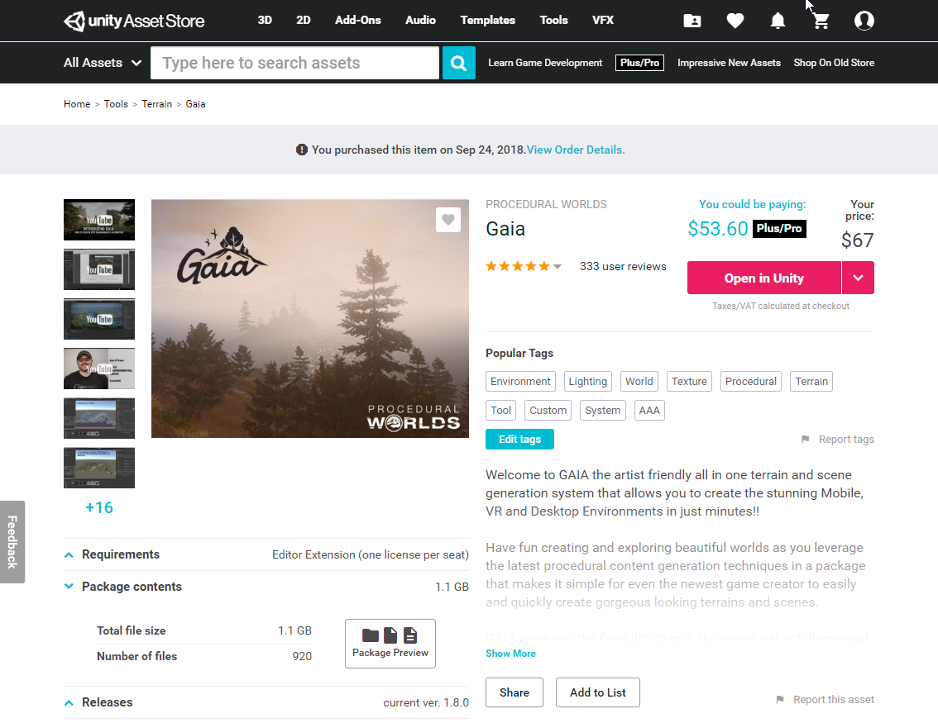

*license type will be asset or editor extension

**Assume users don’t create tags, just pick from a list if they “Edit tags

### Attributes (0NF)

”

### 1NF

### 2NF

### 3NF

### ERD

## Publisher Products View

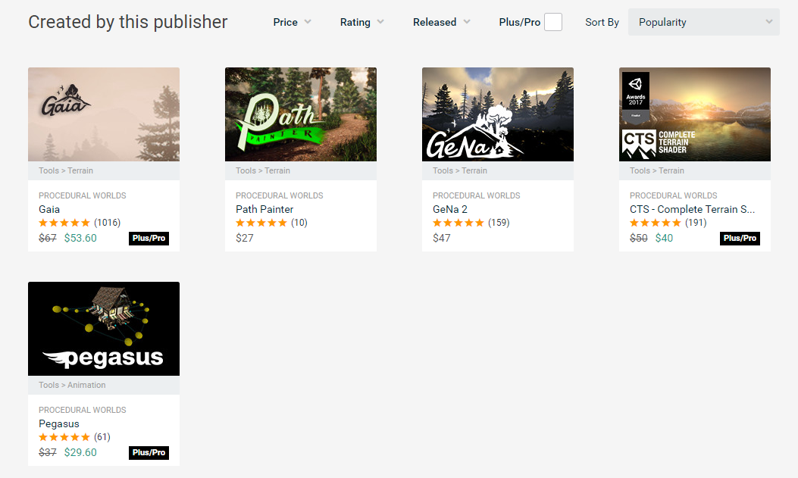

### Attributes (0NF)

* Type will be Plus/Pro or personal

### 1NF

### 2NF

### 3NF

### ERD

## User Profile View

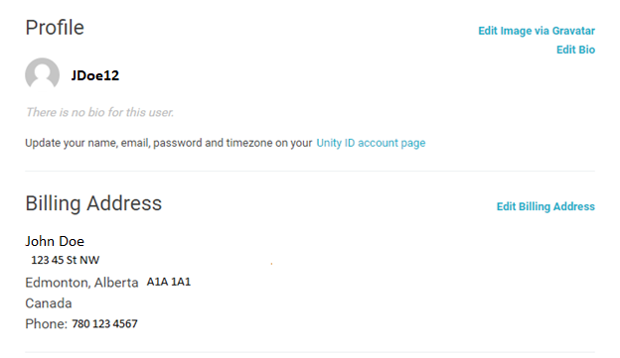

### Attributes (0NF)

*Profile name is based off email

### 1NF

### 2NF

### 3NF

### ERD

## Merged ERD